African Flower Crochet Purse – Part 1

[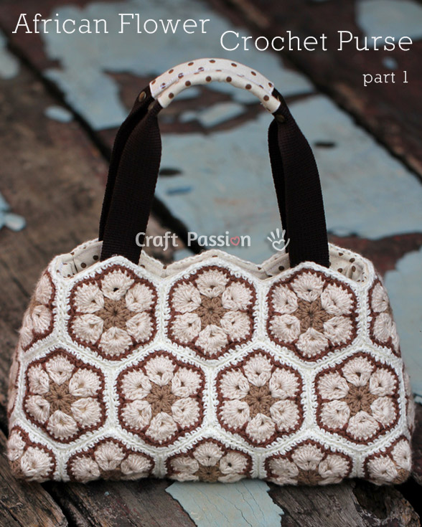](http://www.craftpassion.com/wp-content/gallery/african-flower-purse-1/african-flower-crochet-purse-3.jpg)

**Crochet Pattern**

**Dimension:**  
Bag: 11 1/2″ (W) x 6 1/2″ (H) x 5″ (D)  
Motif: Each flower has a diameter (the widest width across) of 8.3cm [3 1/4"] (including the white border) if using the yarn stated below.  
To convert the measurement, please use the [Conversion tool](http://www.craftpassion.com/conversion" \t "_blank) here.

**Material & Tool:**  
1. Yarn, acrylic baby yarn, [Tilda](http://www.svartafaret.se/garn/tilda/farger) color code: 05, 26, 505 and 510.

Approximate yardage: 50 gram each for 05, 26, 510, 100 gram for 505.

2. Crochet hook, 3mm

**Abbreviations:**  
sl knot = slip knot  
st = stitch  
ss = slip stitch (to fasten)  
ch = chain  
sc = single crochet  
dc = double crochet  
fo = fasten off  
Rnd = round

**Pattern: (Hexagon)**  
Make: 28  
Base Round – light brown: sl knot, ch 6, ss into first ch to make a ring. Or, you can use magic ring.  
Rnd 1 – ch 3, 1 dc, ch1, \*2 dc, ch1, \* repeat until you have six spaces and six 2dc. ss to the 3rd chain of the beginning round. fo  
Rnd 2 – beige : Start in a space. ch 5, 2 dc in same space, \*ch1, 2 dc, ch2, 2 dc in next space – repeat \* 5 times, 1 dc and ss into the 3rd ch of the beginning round.  
Rnd 3 – ch3, dc6 in the 2-ch space, ch1, \* dc7 in next 2-ch space, ch1, repeat \* 5 times. ss the 3rd ch of the beginning round. fo.  
Rnd 4 – dark brown: ch1, sc around and make a long stitch down in round 2 between each flower petal. End with ss. fo.  
Rnd 5 – white: [crochet back loops only] ch1, sc in next 2 sts, \*3sc in next st, sc in next 3 sts, (skip long stitch of the previous round), sc in next 3 sts, repeat 5 times, 3sc in next st, sc in next 3 sts, (skip long stitch of the previous round), ss to the ch from the beginning round.  
FO, keep a long tail for joining.

**Pattern: (Square)**  
Make: 4  
Base Round – light brown: sl knot, ch 4, ss into first ch to make a ring. Or, you can use magic ring.  
Rnd 1 – ch 3, 1 dc, ch1, \*2 dc, ch1, \* repeat until you have four spaces and four 2dc. ss to the 3rd chain of the beginning round. fo  
Rnd 2 – beige : Start in a space. ch 5, 2 dc in same space, \*ch1, 2 dc, ch2, 2 dc in next space – repeat \* 3 times, 1 dc and ss into the 3rd ch of the beginning round.  
Rnd 3 – ch3, dc6 in the 2-ch space, ch1, \* dc7 in next 2-ch space, ch1, repeat \* 3 times. ss the 3rd ch of the beginning round. fo.  
Rnd 4 – dark brown: ch1, sc around and make a long stitch down in round 2 between each flower petal. End with ss. fo.  
Rnd 5 – white: [crochet back loops only] ch1, sc in next 2 sts, \*3sc in next st, sc in next 3 sts, (skip long stitch of the previous round), sc in next 3 sts, repeat 3 times, 3sc in next st, sc in next 3 sts, (skip long stitch of the previous round), ss to the ch from the beginning round.  
FO, keep a long tail for joining.

You can view how to crochet the original African Flower motif [here](http://www.craftpassion.com/2011/04/crochet-african-flower-paperweight-granny.html/2" \t "_blank).

To join, place 2 motifs with right side facing each other, align the stitches, work on wrong side, ss on both front loops only.

[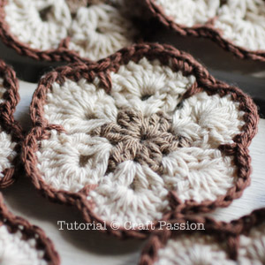](http://www.craftpassion.com/wp-content/uploads/2012/04/crochet-african-flower.jpg)The African Flower motifs before white border.  
[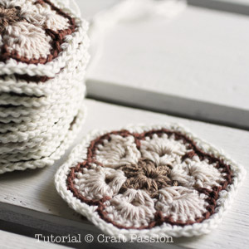](http://www.craftpassion.com/wp-content/uploads/2012/04/crochet-african-flower2.jpg)The African Flower motifs with white border.  
[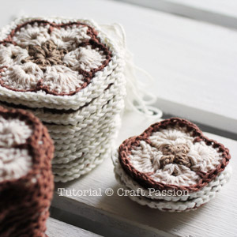](http://www.craftpassion.com/wp-content/uploads/2012/04/crochet-african-flower3.jpg)The purse needs 4 square flowers to make the 4 corners at the base.  
  
[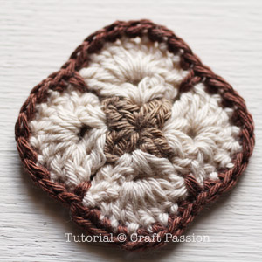](http://www.craftpassion.com/wp-content/uploads/2012/04/crochet-african-flower-square-2.jpg)Square African Flower motif before white border.  
[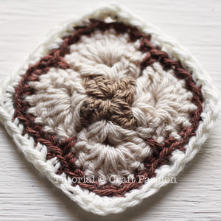](http://www.craftpassion.com/wp-content/uploads/2012/04/crochet-african-flower-square-1.jpg)Square African Flower motif after white border.  
[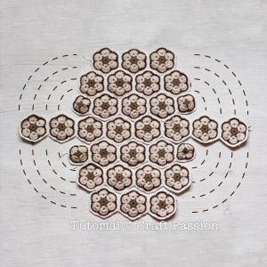](http://www.craftpassion.com/wp-content/uploads/2012/04/crochet-african-flower-pattern.jpg)After all the motifs are done, arrange them in this way.  
3  
4  
3 (with 2 square at both sides)  
8  
3 (with 2 square at both sides)  
4  
3  
[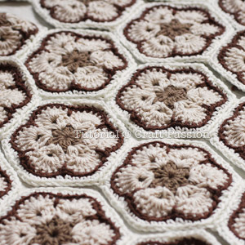](http://www.craftpassion.com/wp-content/uploads/2012/04/crochet-african-flower-arrangement.jpg)Join the motif on their vertical sides, crochet slips stitches on the front loops only to join the flowers from the wrong side.  
Use the same color yarn, join the rows to make them into purse that looks like the one below.  
[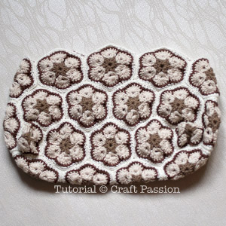](http://www.craftpassion.com/wp-content/uploads/2012/04/african-flower-crochet-bag-1.jpg)[The next tutorial (part 2)](http://www.craftpassion.com/2012/04/african-flower-crochet-purse-part-2.html) will be on sewing the lining and handles to complete the African Flower Purse.  
If you are happy with the purse without lining, you can always put on the handle and use it now but I swear that the purse will look more elegant and stable with a lining on.  
  
[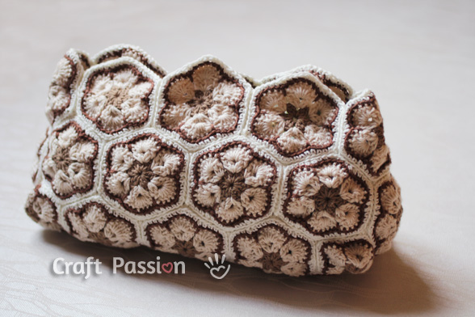](http://www.craftpassion.com/wp-content/gallery/african-flower-purse-1/crochet-african-flower-bag-2.jpg)

{More photos and story on [**Page 1**](http://www.craftpassion.com/2012/04/african-flower-crochet-purse-part-1.html).}